Connecticut Coastal

ADS-40 Imagery Collection Project



ADS40 Imagery Collection Project

Connecticut Coastal

EarthData International of Maryland, Inc requested the collection of ADS-40 imagery data over Coastal Connecticut. The data was collected to support the generation of natural color and color infrared ortho-photographs with a 0.50 meter ground sample distance (GSD). In response EarthData Aviation acquired image data on September 20th and September 22nd, 2004. The collection was performed using Horizons’ Cessna Conquest with tail number N93HC. Image data was captured using Leica ADS40 camera systems, including an inertial measuring unit (IMU) and a dual frequency GPS receiver.

GPS Data Collection

During airborne data collection, a network of ground GPS receivers was in constant operation during data collection. All stations used were tied to the National Geodetic Survey (NGS) Continuously Operating Reference Station (CORS) network. For each lift, the flight crew set up a 1 second GPS receiver on an NGS published point. The CORS stations served as secondary receivers to ensure adequate coverage during flight.

Base station identifiers and their corresponding coordinates are listed in the table below, along with the lift numbers in which they were used as the primary base station. CORS stations and NGS published points are listed by the NGS identifiers, while temporary points use field crew nomenclature.

Lift Number | Base Station Name | Base Latitude (N) | Base longitude (W) | Ellipsoidal Height (m)
 |  | (ddd-mm-ss.sss) | (ddd-mm-ss.sss)
26404B | A15582 | N 41 16 04.79476 | W 072 53 18.39305 | -28.56
26604A | DF8964 | N 40 47 03.55012 | W 073 05 49.78136 | 7.65

GPS Data Processing

All GPS phase data was post processed with continuous kinematic survey techniques using “On the Fly” (OTF) integer ambiguity resolution. The GPS data was processed with forward and reverse processing algorithms. The results from each process, using the data collected at the airport, were combined to yield a single fixed integer phase differential solution of the aircraft trajectory. Plots of altitude and the forward and reverse GPS solution residuals are attached. The difference between the forward to reverse solutions for each lift indicate valid and accurate solutions. These differences are summarized in the table below:

Lift | Date | Forward – Reverse Separations (meters)
Lift | Date | Horizontal Component | Vertical Component
26404B | 09/20/2004 | .06 | .17
26604A | 09/22/2004 | .06 | .22

Orientation Data Processing

An IMU was used to record precise changes in position and orientation of the ADS-40 camera at a rate of 200 Hz. All IMU data was processed post flight with a Kalman filter to integrate inertial measurements and precise phase differential GPS positions. The resulting solution contains geodetic position, omega, phi, kappa, and time for subsequent merging with the laser ranging information.

ADS-40 Data Collection

The areas of interest were flown at an altitude of 15,750 feet above mean terrain. The ADS-40 collection specifications follow:

Sensor Collection Parameters
Flying Height | 15,750 feet AMT
Target Airspeed | 270 knots
Desired GSD | 0.50 meters
Camera Cycle Time | 3.6 ms
Collection Mode | Standard All

The table below summarizes the data collection by date:

Data Collection By Date
Lift | Date | Lines Collected
26404B | 09/20/2004 | 2 - 17
26604A | 09/22/2004 | 17,3,19,18, 20,1

ADS-40 Data Quality Control

Prior to data delivery, the ADS-40 imagery was examined by EarthData Aviation to assure the data quality. This quality control check involved examining raw images from every array of the ADS-40 for every flight. These images were examined for any data anomalies that might occur such as pixel drop-outs. In addition to this check of the raw images, the nadir image from each flightline was rectified to a plane at a subsampled pixel resolution. These georeferenced images were imported into viewing software and then examined. The examination of the rectified images was used to identify any clouds, cloud shadows, data gaps, smoke, etc… Any possible issues that were identified during this QC were then addressed on a case by case basis and reflights were scheduled where applicable.
GPS Processing Graphs

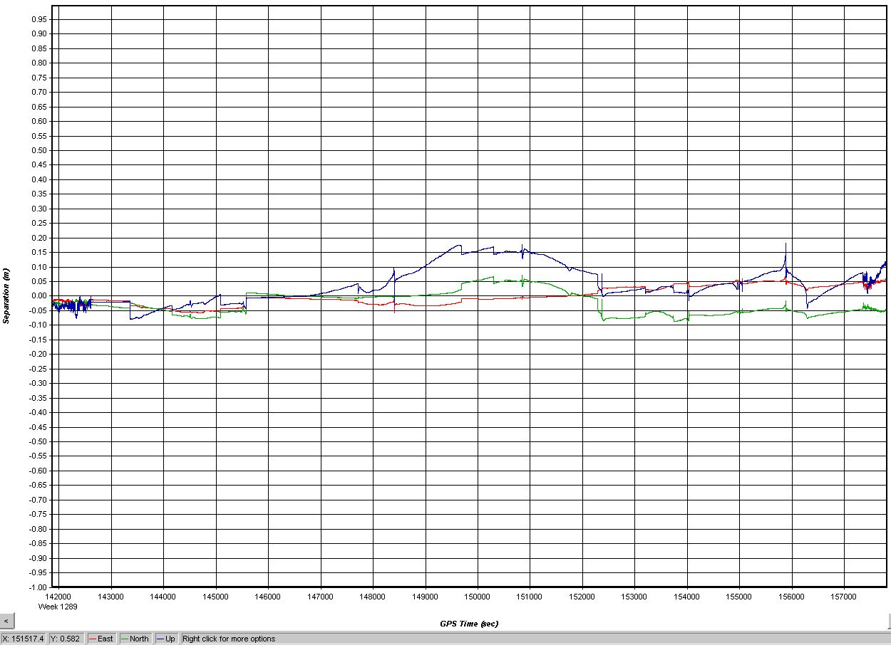

Forward-Reverse Solution Residuals
Lift 26404A: 20 September 2004

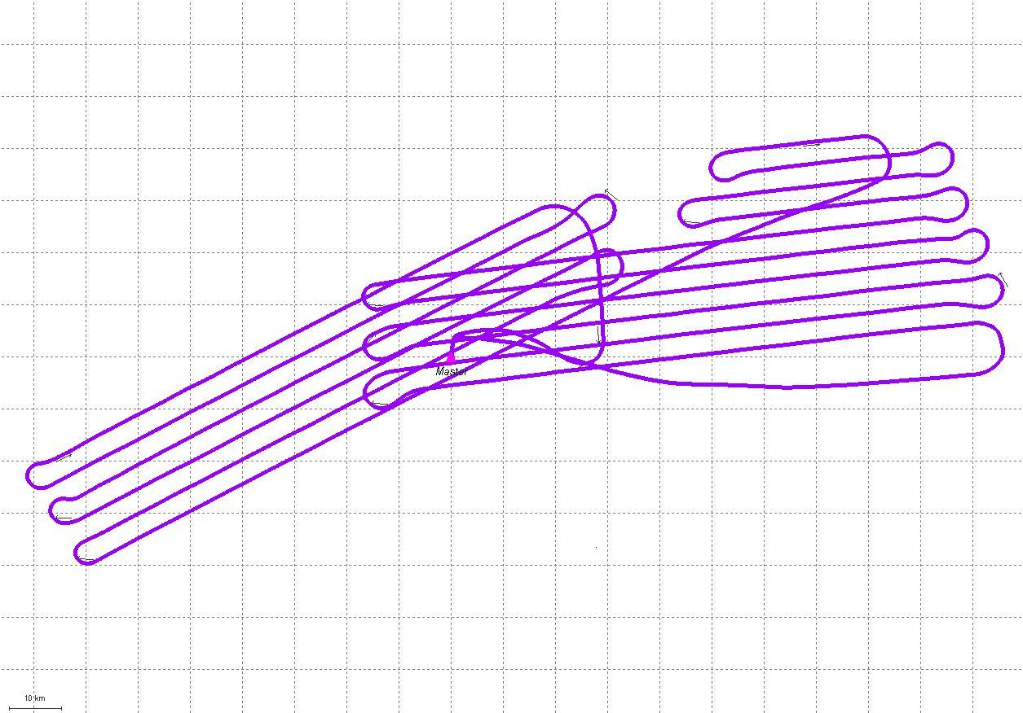

Aircraft Trajectory Plot
Lift 26404A: 20 September 2004

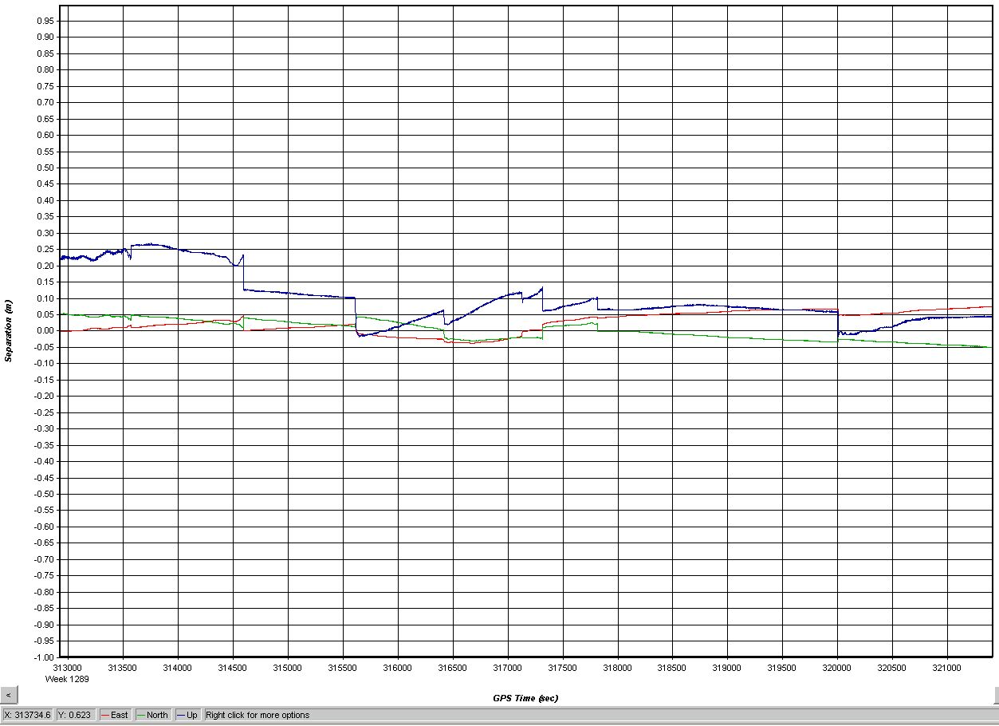

Forward-Reverse Solution Residuals
Lift 26604A: 22 September 2004

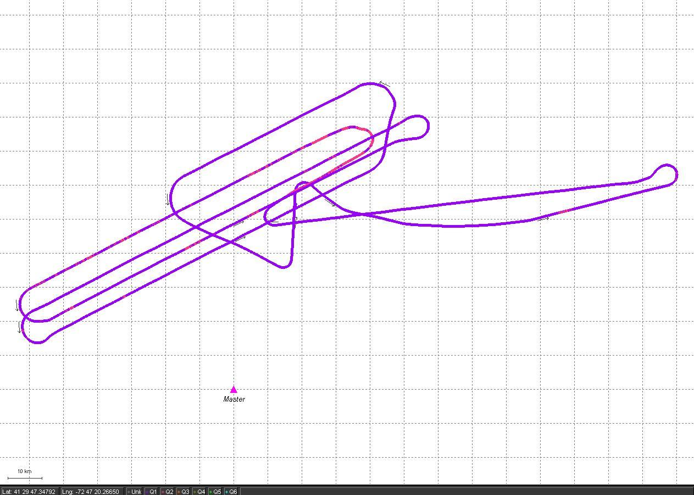

Aircraft Trajectory Plot
Lift 26604A: 22 September 2004

NGS Datasheets

National Geodetic Survey, Retrieval Date = SEPTEMBER 17, 2004
AI5582 ***********************************************************************
AI5582 PACS - This is a Primary Airport Control Station.
AI5582 DESIGNATION - HVN D
AI5582 PID - AI5582
AI5582 STATE/COUNTY- CT/NEW HAVEN
AI5582 USGS QUAD - NEW HAVEN (1984)
AI5582
AI5582 *CURRENT SURVEY CONTROL
AI5582 ___________________________________________________________________
AI5582* NAD 83(1996)- 41 16 04.79476(N) 072 53 18.39305(W) ADJUSTED
AI5582* NAVD 88 - 1.33 (meters) 4.4 (feet) GPS OBS
AI5582 ___________________________________________________________________
AI5582 X - 1,412,610.498 (meters) COMP
AI5582 Y - -4,588,468.632 (meters) COMP
AI5582 Z - 4,184,821.020 (meters) COMP
AI5582 LAPLACE CORR- -2.73 (seconds) DEFLEC99
AI5582 ELLIP HEIGHT- -28.56 (meters) (06/04/02) GPS OBS
AI5582 GEOID HEIGHT- -29.90 (meters) GEOID03
AI5582
AI5582 HORZ ORDER - B
AI5582 ELLP ORDER - FOURTH CLASS I
AI5582
AI5582.This mark is at Tweed-New Haven Airport (HVN)
AI5582
AI5582.The horizontal coordinates were established by GPS observations
AI5582.and adjusted by the National Geodetic Survey in May 2000.
AI5582
AI5582.The orthometric height was determined by GPS observations and a
AI5582.high-resolution geoid model.
AI5582
AI5582.GPS derived orthometric heights for airport stations designated as
AI5582.PACS or SACS are published to 2 decimal places. This maintains
AI5582.centimeter relative accuracy between the PACS and SACS. It does
AI5582.not indicate centimeter accuracy relative to other marks which are
AI5582.part of the NAVD 88 network.
AI5582
AI5582.Photographs are available for this station.
AI5582
AI5582.The X, Y, and Z were computed from the position and the ellipsoidal ht.
AI5582
AI5582.The Laplace correction was computed from DEFLEC99 derived deflections.
AI5582
AI5582.The ellipsoidal height was determined by GPS observations
AI5582.and is referenced to NAD 83.
AI5582
AI5582.The geoid height was determined by GEOID03.
AI5582
AI5582; North East Units Scale Factor Converg.
AI5582;SPC CT - 200,682.299 293,200.107 MT 0.99999383 -0 05 30.5
AI5582;UTM 18 - 4,570,658.327 676,869.238 MT 0.99998501 +1 23 35.2
AI5582
AI5582! - Elev Factor x Scale Factor = Combined Factor
AI5582!SPC CT - 1.00000448 x 0.99999383 = 0.99999831
AI5582!UTM 18 - 1.00000448 x 0.99998501 = 0.99998949
AI5582
AI5582 SUPERSEDED SURVEY CONTROL
AI5582
AI5582 ELLIP H (05/22/00) -28.55 (m) GP( ) 4 1
AI5582
AI5582.Superseded values are not recommended for survey control.
AI5582.NGS no longer adjusts projects to the NAD 27 or NGVD 29 datums.
AI5582.See file dsdata.txt to determine how the superseded data were derived.
AI5582
AI5582_U.S. NATIONAL GRID SPATIAL ADDRESS: 18TXL7686970658(NAD 83)
AI5582_MARKER: I = METAL ROD
AI5582_SETTING: 59 = STAINLESS STEEL ROD IN SLEEVE (10 FT.+)
AI5582_STAMPING: HVN D 1999
AI5582_MARK LOGO: NGS
AI5582_PROJECTION: RECESSED 2 CENTIMETERS
AI5582_MAGNETIC: N = NO MAGNETIC MATERIAL
AI5582_STABILITY: B = PROBABLY HOLD POSITION/ELEVATION WELL
AI5582_SATELLITE: THE SITE LOCATION WAS REPORTED AS SUITABLE FOR
AI5582+SATELLITE: SATELLITE OBSERVATIONS - 1999
AI5582_ROD/PIPE-DEPTH: 9.4 meters
AI5582_SLEEVE-DEPTH : 1 meters
AI5582
AI5582 HISTORY - Date Condition Report By
AI5582 HISTORY - 1999 MONUMENTED WOOLPT
AI5582
AI5582 STATION DESCRIPTION
AI5582
AI5582'DESCRIBED BY WOOLPERT CONSULTANTS 1999 (ARL)
AI5582'THE STATION IS LOCATED APPROXIMATELY 4.1 MI (6.6 KM) SOUTHEAST OF NEW
AI5582'HAVEN, 1.3 MI (2.1 KM) SOUTHWEST OF EAST HAVEN AND IS LOCATED AT THE
AI5582'TWEED-NEW HAVEN AIRPORT. OWNERSHIP-- TWEED-NEW HAVEN AIRPORT, 155
AI5582'BURR STREET ADMINISTRATION BUILDING 2ND FLOOR, NEW HAVEN CT, 06512,
AI5582'C/O RICHARD LAMPORT AIRPORT MANAGER. PHONE NUMBER (203) 466-8833, FAX
AI5582'NUMBER (203) 466-8844. CONTACT THE AIRPORT MANAGER AT LEAST 24 HOURS
AI5582'PRIOR TO ARRANGE FOR ACCESS.
AI5582'TO REACH THE STATION FROM THE JUNCTION OF INTERSTATE 95 AND STATE
AI5582'ROUTE 337 SOUTH (BURR STREET) , PROCEED SOUTHERLY 1.35 MI (2.17 KM)
AI5582'ALONG BURR STRRET TO THE JUNCTION OF DODGE AVENUE ON THE LEFT. TURN
AI5582'LEFT AND PROCEED EASTERLY 1.60 MI (2.57 KM) ALONG DODGE AVENUE TO THE
AI5582'JUNCTION OF THOMAS STREET. TURN RIGHT AND PROCEED SOUTHERLY 0.2 MI
AI5582'(0.3 KM) ALONG THOMAS STREET TO A PARKING LOT ENTRANCE ON THE RIGHT.
AI5582'TURN RIGHT AND CONTINUE SOUTHERLY 0.3 MI (0.5 KM) ALONG A ROAD AT THE
AI5582'EDGE OF THE PARKING LOT TO A GATE LEADING TO THE MAINTANCE AREA.
AI5582'PROCEED THROUGH THE GATE AND ALONG THE ROAD SOUTHWESTERLY 0.1 MI (0.2
AI5582'KM) TO THE JUNCTION OF TWY CHARLIE. TURN RIGHT AND PROCEED NORTHWEST
AI5582'0.20 MI (0.32 KM) ON TWY CHARLIE, CROSSING RWY 2-10, TO THE STATION ON
AI5582'THE RIGHT, IN THE INFIELD FORMED BY TWY CHARLIE, RWY 2-20, AND THE
AI5582'TERMINAL RAMP. THE STATION IS ONLINE WITH THE SECOND SET OF RWY
AI5582'LIGHTS NORTH OF TWY CHARLIE.
AI5582'THE STATION IS LOCATED 67.8 M (222.4 FT) NORTH 54 DEGREES EAST OF THE
AI5582'EDGE OF PAVEMENT OF TWY CHARLIE, 61.0 M (200.1 FT) NORTH 73 DEGREES
AI5582'WEST OF THE SECOND SET OF RWY LIGHTS NORTH OF TWY CHARLIE, AND 29.3 M
AI5582'(96.1 FT) NORTH OF A SQUARE CATCH BASIN. THE STATION IS A STAINLESS
AI5582'STEEL ROD WITH A PUNCHMARK DRIVEN TO A SLOW DRIVING RATE AT A DEPTH OF
AI5582'9.4 M, (30.8 FT) ENCASED IN A 1 M (3.3 FT) FINNED SLEEVE FILLED WITH
AI5582'NON-TOXIC GREASE, RECESSED 8 CM BENEATH A STANDARD NGS LOGO CAP
AI5582'STAMPED-- HVN D 1999-- ENCASED IN A 0.3 M (1.0 FT) DIAMETER CONCRETE
AI5582'COLLAR AND RECESSED 2 CM BELOW THE GROUND. THIS STATION IS DESIGNATED
AI5582'AS THE PRIMARY AIRPORT CONTROL STATION.

DF4064 ***********************************************************************
DF4064 CORS - This is a GPS Continuously Operating Reference Station.
DF4064 DESIGNATION - NEW YORK WAAS 1 CORS ARP
DF4064 CORS_ID - ZNY1
DF4064 PID - DF4064
DF4064 STATE/COUNTY- NY/SUFFOLK
DF4064 USGS QUAD - PATCHOGUE (1967)
DF4064
DF4064 *CURRENT SURVEY CONTROL
DF4064 ___________________________________________________________________
DF4064* NAD 83(CORS)- 40 47 03.55019(N) 073 05 49.78137(W) ADJUSTED
DF4064* NAVD 88 -
DF4064 ___________________________________________________________________
DF4064 EPOCH DATE - 2002.00
DF4064 X - 1,406,145.344 (meters) COMP
DF4064 Y - -4,627,345.099 (meters) COMP
DF4064 Z - 4,144,321.822 (meters) COMP
DF4064 ELLIP HEIGHT- 7.26 (meters) (02/??/03) GPS OBS
DF4064 GEOID HEIGHT- -31.09 (meters) GEOID03
DF4064
DF4064 HORZ ORDER - SPECIAL (CORS)
DF4064 ELLP ORDER - SPECIAL (CORS)
DF4064
DF4064.ITRF positions are available for this station.
DF4064.The coordinates were established by GPS observations
DF4064.and adjusted by the National Geodetic Survey in February 2003.
DF4064.The coordinates are valid at the epoch date displayed above.
DF4064.The epoch date for horizontal control is a decimal equivalence
DF4064.of Year/Month/Day.
DF4064
DF4064
DF4064.The PID for the CORS L1 Phase Center is DF8964.
DF4064
DF4064.The XYZ, and position/ellipsoidal ht. are equivalent.
DF4064
DF4064.The ellipsoidal height was determined by GPS observations
DF4064.and is referenced to NAD 83.
DF4064
DF4064.The geoid height was determined by GEOID03.
DF4064
DF4064; North East Units Scale Factor Converg.
DF4064;SPC NY L - 68,980.664 376,205.870 MT 0.99999556 +0 35 25.9
DF4064
DF4064! - Elev Factor x Scale Factor = Combined Factor
DF4064!SPC NY L - 0.99999886 x 0.99999556 = 0.99999442
DF4064
DF4064 SUPERSEDED SURVEY CONTROL
DF4064
DF4064.No superseded survey control is available for this station.
DF4064
DF4064_U.S. NATIONAL GRID SPATIAL ADDRESS: 18TXL6055716557(NAD 83)
DF4064_MARKER: STATION IS THE ANTENNA REFERENCE POINT OF THE GPS ANTENNA
DF4064
DF4064 STATION DESCRIPTION
DF4064
DF4064'DESCRIBED BY NATIONAL GEODETIC SURVEY 2003
DF4064'STATION IS A GPS CORS. LATEST INFORMATION INCLUDING POSITIONS AND
DF4064'VELOCITIES ARE AVAILABLE IN THE COORDINATE AND LOG FILES ACCESSIBLE
DF4064'BY ANONYMOUS FTP OR THE WORLDWIDE WEB.
DF4064' FTP CORS.NGS.NOAA.GOV: CORS/COORD AND CORS/STATION_LOG
DF4064' HTTP://WWW.NGS.NOAA.GOV UNDER PRODUCTS AND SERVICES.
DF8964 ***********************************************************************
DF8964 CORS - This is a GPS Continuously Operating Reference Station.
DF8964 DESIGNATION - NEW YORK WAAS 1 CORS L1 PHASE CENTER
DF8964 CORS_ID - ZNY1
DF8964 PID - DF8964
DF8964 STATE/COUNTY- NY/SUFFOLK
DF8964 USGS QUAD - PATCHOGUE (1967)
DF8964
DF8964 *CURRENT SURVEY CONTROL
DF8964 ___________________________________________________________________
DF8964* NAD 83(CORS)- 40 47 03.55012(N) 073 05 49.78136(W) ADJUSTED
DF8964* NAVD 88 -
DF8964 ___________________________________________________________________
DF8964 EPOCH DATE - 2002.00
DF8964 X - 1,406,145.430 (meters) COMP
DF8964 Y - -4,627,345.382 (meters) COMP
DF8964 Z - 4,144,322.076 (meters) COMP
DF8964 ELLIP HEIGHT- 7.65 (meters) (02/??/03) GPS OBS
DF8964 GEOID HEIGHT- -31.09 (meters) GEOID03
DF8964
DF8964 HORZ ORDER - SPECIAL (CORS)
DF8964 ELLP ORDER - SPECIAL (CORS)
DF8964
DF8964.ITRF positions are available for this station.
DF8964.The coordinates were established by GPS observations
DF8964.and adjusted by the National Geodetic Survey in February 2003.
DF8964.The coordinates are valid at the epoch date displayed above.
DF8964.The epoch date for horizontal control is a decimal equivalence
DF8964.of Year/Month/Day.
DF8964
DF8964
DF8964.The PID for the CORS ARP is DF4064.
DF8964
DF8964.The XYZ, and position/ellipsoidal ht. are equivalent.
DF8964
DF8964.The ellipsoidal height was determined by GPS observations
DF8964.and is referenced to NAD 83.
DF8964
DF8964.The geoid height was determined by GEOID03.
DF8964
DF8964; North East Units Scale Factor Converg.
DF8964;SPC NY L - 68,980.662 376,205.870 MT 0.99999556 +0 35 25.9
DF8964
DF8964! - Elev Factor x Scale Factor = Combined Factor
DF8964!SPC NY L - 0.99999880 x 0.99999556 = 0.99999436
DF8964
DF8964 SUPERSEDED SURVEY CONTROL
DF8964
DF8964.No superseded survey control is available for this station.
DF8964
DF8964_U.S. NATIONAL GRID SPATIAL ADDRESS: 18TXL6055716557(NAD 83)
DF8964_MARKER: STATION IS THE L1 PHASE CENTER OF THE GPS ANTENNA
DF8964
DF8964 STATION DESCRIPTION
DF8964
DF8964'DESCRIBED BY NATIONAL GEODETIC SURVEY
DF8964'STATION IS A GPS CORS. LATEST INFORMATION INCLUDING POSITIONS AND
DF8964'VELOCITIES ARE AVAILABLE IN THE COORDINATE AND LOG FILES ACCESSIBLE
DF8964'BY ANONYMOUS FTP OR THE WORLDWIDE WEB.
DF8964' FTP CORS.NGS.NOAA.GOV: CORS/COORD AND CORS/STATION_LOG
DF8964' HTTP://WWW.NGS.NOAA.GOV UNDER PRODUCTS AND SERVICES.

